**ABSTRACT**

The objective of this report is to highlight the project report of team

**The Vanquishers**

Go-Kart vehicle to compete in various competition.

**ABOUT TEAM**

The Team’s primary objective is to design a safe and functional vehicle based on a rigid and torsion-free frame, well mounted power train and to understand the finer aspects of vehicle design with the ulterior motive of fabricating prototype vehicle that could be manufactured for consumer sale, while strictly adhering to the competition rule. The secondary objective is to enhance driver’s comfort and safety, and to increase the performance and maneuverability of the vehicle.

This paper concentrates on explaining the design and engineering aspects of making a Go Kart for various karting championships 2017. This report explains objectives, assumptions and calculations made in designing a Go Kart. The team’s primary objective is to design a safe and functional vehicle based on rigid and torsion free frame. The design is chosen such that the Kart is easy to fabricate in every possible aspect

To achieve our goal the team has been divided into core groups responsible for the design and optimization of major sub-systems which were later integrated into the final blueprint.

**INTRODUCTION**

We approached our design by considering all possible alternatives for a system & modelling them in CAD software like solidworks etc. and subjected to analysis using ANSYS FEA software. Based on analyses result, the model was modified and retested and a final design was frozen. The design process of the vehicle is iterative and is based on various engineering and reverse engineering processes depending upon the availability, cost and other such factors

So the design process focuses on following objectives:

* **Safety**
* **Serviceability**
* **Strength**
* **Ruggedness**
* **Standardization**
* **Cost**
* **Driving feel and ergonomics**
* **Aesthetics**

Optimizing the design by avoiding over designing, which would also help in reducing the cost. With this we had a view of our kart. This started our goal and we set up some parameters for our work, distributed ourselves in groups.

**Sub-Teams for Design**

* **Frame design**
* **Body and Composites**
* **Steering system design**
* **Brake and Wheels**
* **Drive train design**
* **Electrical design**

**DESIGN OF KART**

The design section of this report is broken into four major topics-

* The design objectives
* The design calculations and analysis
* Considerations
* Testing

Based on the overall design objectives of durability, performance, and light- weight design, the component is evaluated by the design team and must meet all of the criteria to become a part of the overall successful design alternatives were also considered during each process and testing commenced once the chosen design met the design objectives.

**FRAME DESIGN**

**OBJECTIVE**

The frame is designed to meet the technical requirements of competition the objective of the chassis is to encapsulate all components of the kart, including a driver, efficiently and safely. Principal aspects of the chassis focused on during the design and implementation included driver safety, drive train integration, and structural weight, and operator ergonomic. The number one priority in the chassis design was driver safety. By the competition rules and Finite Element Analysis (FEA), the design assured.

**DESIGN**

The main component of the frame are divided into the two major parts first the front block (cockpit) for steering and seat positions etc. and second rear block (engine compartment) for transmission and brake assembly. Both the blocks are separated by the firewall. The frame modal can be viewed as shown below-

**MATERIAL**

The material SAE-1018 is used in the frame design because of its good weld ability relatively soft and strengthens as well as good manufacturability. A good strength material is important in a roll cage because the roll cage needs to absorb as much energy as possible to prevent the roll cage material from fracturing at the time of high impact. SAE-1018 has chosen for the chassis because it has structural properties that provide a low weight to strength ratio.

The dimensions of the material is assured by analysis in ANSYS software. The various Physical properties of the material are as follow:

|  |  |  |
| --- | --- | --- |
| S.N | PROPERTIES | VALUES |
|  |  |  |
| 1) | Tensile strength, Ultimate | 450 MPa |
|  |  |  |
| 2) | Tensile strength, Yield | 380 MPa |
|  |  |  |
| 3) | Bulk Modulus | 200 GPa |
|  |  |  |
| 4) | Shear Modulus | 80 Gpa |
|  |  |  |
| 5) | Modulus of Elasticity | 200 GPa |
|  |  |  |
| 6) | Poisson’s ratio | 0.29 |
|  |  |  |
| 7) | Elongation at break | 16% |
|  |  |  |

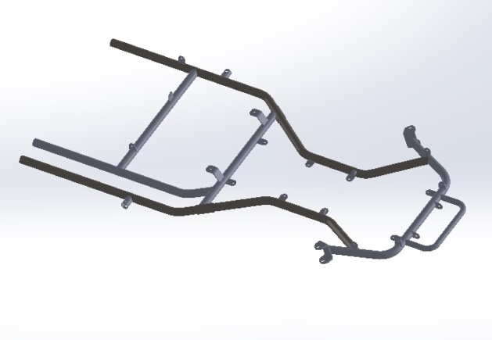

The chemical composition of the material is as –

Carbon C = 0.18

Manganese Mn = 0.73%

Silicon Si = 0.18%

Sulphur S = 0.017%

Phosphorus P = 0.020%

The above mentioned properties satisfy the technical requirement of material which is to be used in frame.

**SAFETY**

Roll cage feature were first implemented by keeping on mind the safety requirement of the event .The first primary safety standard focused on during design was maintaining the proper clearance of the driver’s body rest to the other rigid parts like engine compartment, firewall structure, and panel bracing of the vehicle. Once the basic requirements fulfilled the other safety design were implemented. The chassis was designed to give occupant extra space to operate the vehicle easily. The place of the fire extinguisher is designed in the easily accessible point and also the earthen foam padding is provided over the pipes adjacent to driver

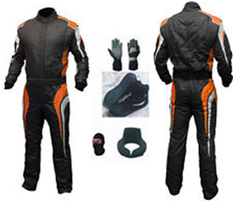

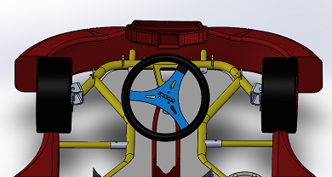

**(VISION ANGLE)**

**FRAME FEA SAFETY ANALYSIS-**

Analysis was conducted by use of finite element analysis FEA on ANSYS software. To conduct finite element analysis of the chassis an existing design of chassis was uploaded from the computer stresses were calculated by simulating three different induced load cases . -

**FRONT IMPACT ANALYSIS-**

Generally in the case of pure elastic collision in frontal impact the linear velocity remains at 64 Kmph according to ENCAP (The European new car assessment program) Hence the value of force is calculated by mass moment equation that is-

F = P/∆T

Where ∆T is the duration of time, generally the collision takes place for a very short duration of time. We assumed this time as ∆T = 1.10 seconds.

And the gross weight of the vehicle is Estimated some around (M=170 KG), hence the moment of the vehicle at 64 Kmph or 17.8 m/s that is-

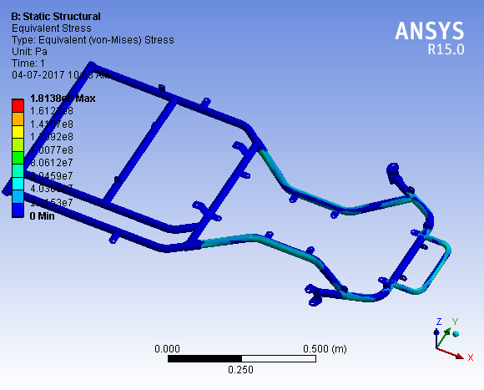

P = M × V

P = 170 × 17.8

P = 3026 kg m/s

And the frontal impact force i.e.-

F = P / ∆T

F = 3026/ 1.10

F =2750.9 N

Now the calculated force were placed on the frontal part of frame by keeping the rear part fix on ANSYS the **result along with the image as above**

**COST and WEIGHT REPORT**

**SIDE IMPACT ANALYSIS** –

In the case of collision by side impact the value of the impact force generated is calculated in the same way as in front impact.

For the side impact the velocity of vehicle is taken 48 kmph or 13.3m/s according to ENCAP Standard and then the force Is calculated i.e.-

F = P / ∆T

Where, P = M × V

P = 170 × 13.3

P =2261 kg m/s

The side impact force

F = 2261 / 1.10

F = 2055.4 N.

Hence the calculated force were placed on one side of the modal of frame while keeping another side fixed and the stresses were simulated the image is shown as below.

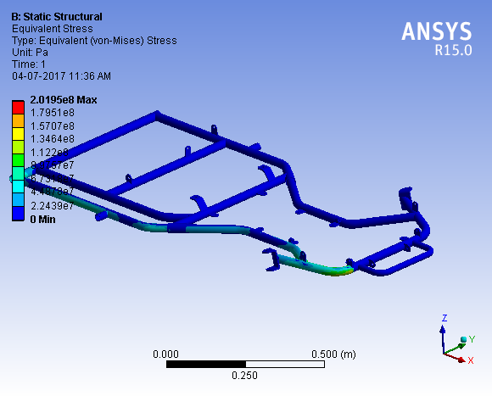

**REAR IMPACT ANALYSIS** –

The rear impact force is also calculated in the same way as remaining two. In this case the velocity of collision were taken 55kmph or 15.5m/s by the calculations and also as according to the ENCAP standards .the calculations are as-

P = M × V

P = 170 × 15.5

P = 2635 kg m/s

And the rear impact force-

F = P/ ∆T

F = 2635/ 1.10

F = 2395 N

Hence the calculated value of the rear impact force was placed on the rear part of the frame while keeping the frontal part fixed. The analysis result is shown as:-

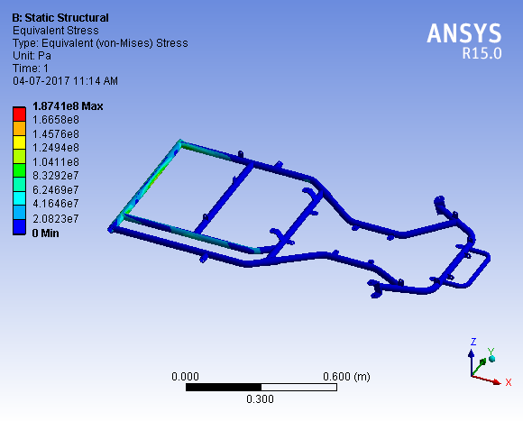

**F.O.S = YIELD STRESS / DESIGN STRESS**

The results from these different analysis modes are accurate for the type and amount of loading that was applied to the known material and geometry. They also assure the safety of the frame in the different cases of impacts. However, these loading

scenarios generally do not exactly represent actual impact modes.

To accurately depict an impact or collision incident, dynamic loading would have to be used to simulate the types of impact loading that would occur during an actual collision. It would be very difficult to accurately model this event without known data gathered from an actual collision in various lateral position along with the longitudinal directions. This data could be gathered using strain gauges attached to the frame of the vehicle.

|  |  |  |  |
| --- | --- | --- | --- |
| FACTORS | **FRONT** | **REAR** | **SIDE** |
|  |  |  |  |
| Impact | 2750.9 | 2395.4 | 2055.4 |
| force |  |  |  |
|  |  |  |  |
| Stress |  |  |  |
| Generated | 181.3 | 187 | 201.95 |
|  |  |  |  |
| Total |  |  |  |
| Deformation | 2.45 mm | 1.03 mm | 1.93 mm |
|  |  |  |  |
| F.O.S. | 2.09 | 2.03 | 1.89 |
|  |  |  |  |

With the data collected from the FEA simulations, the roll cage was found to have a max theoretical factor of safety of approximately 2.09.

**FRAME DESIGN CONSIDERATIONS**

**WEIGHT –**

The final weight of the chassis was measured on software is 22kg and the gross (final) weight of the vehicle along with the driver is estimated to be 170 kg.

|  |  |  |
| --- | --- | --- |
| CONSIDERATION | PRIORITY | REASON |
|  |  |  |
| Light weight | Essential | A light car is a |
|  |  | fast race car |
|  |  |  |
| Durable | Essential | Must not |
|  |  | deform during |
|  |  | rugged driving |
|  |  |  |
| Meet Requirements | Essential | Must meet |
|  |  | requirements to |
|  |  | compete |
| Simple frame | High | Majority of |
|  |  | frame |
|  |  | fabrication |
|  |  | done in |
|  |  | workshop |
| Attractive Design | Desired | Easier to sell |
|  |  | an aesthetically |
|  |  | pleasing |
|  |  | vehicle |
| Cost | Low | Car needs to |
|  |  | be within |
|  |  | budget |
|  |  |  |

**ASTHETIC**

Aesthetically, the roll cage design is improved by the use of more rounded corners than the straight. The unique use of rounded corners allows for a more pleasing look to the vehicle’s body as well as a reduced number of welded joints.

**MANUFACTURABILITY**

All design work for the go kart championship has done In the SOLIDWORKS software. Using this program to produce three dimensional model allowed easy revision of prebuilt designs, and gave design team members a visual picture of what the frame would look like.

**BODY AND COMPOSITES**

**OBJECTIVES**

The purpose of the body is to prevent debris from entering the vehicle, with the intent of protecting the driver and the vehicle’s components. The seat was designed to support the driver comfortably and safely while they are operating the vehicle.

**DESIGN**

The design of the body and composites has done in the cad software and the FRP is selected for the body works of very less weight.

**BODY PANELS-**

The body panels are made out of .080 inch thick FRP ( fiber reinforced plastic) .FRP is a composite material made of a matrix reinforced with fibers the polymer is usually epoxy, vinlester or polyster thermosetting plastic are used in FRP. It is very light material that has desirable properties for a body panel..

**SEAT**-

The seat in this kart is also designed to be very light it is very simple made of plastic material and is positioned at 17 degrees to give a better vision angle.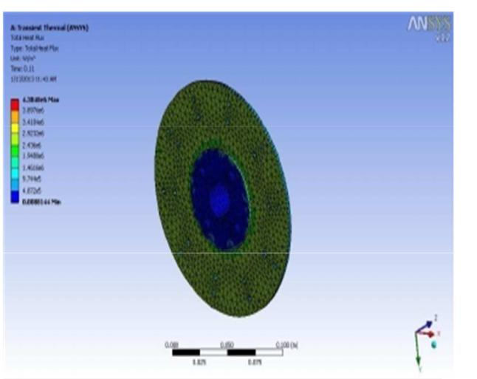

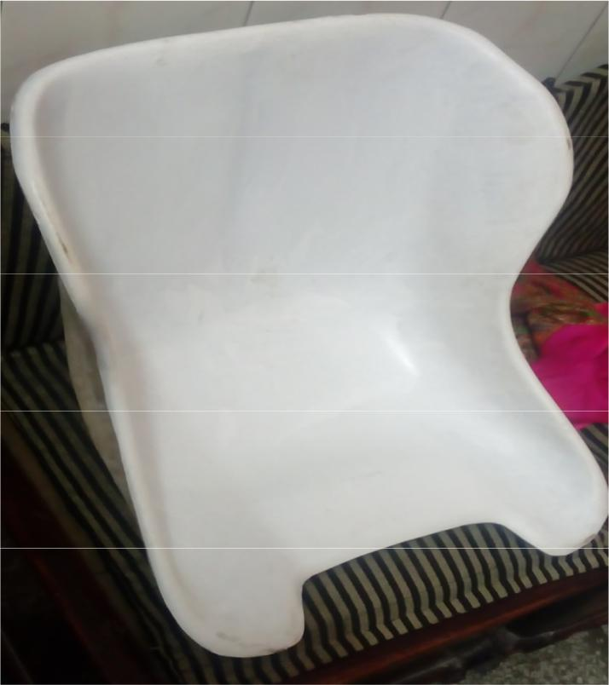

**STEERING SYSTEM DESIGN**

***OBJECTIVE***

The steering system is designed to withstand the stress of safely maneuvering the vehicle through any type of possible condition at the time of driving. The purpose of the steering system is to provide directional control of the vehicle with minimum input. The main goal for steering is to have steering radius of 4m or less and to have 100% Ackerman steering.

**DESIGN**

Simplicity and safety were the main design specifications for the vehicle’s steering system. While designing the steering system the constraints that we possessed were center alignment of steering system, track width, human effort at the steering wheel and the desired response of the steering system. A Pivot Pin steering arrangement was chosen due to its light weight, simple design and low cost. Very less play due to limited number of joints. We are also introduced the multi sensitive steering system. This system has a tendency to increase or decrease the sensitivity of our steering by means of multiport pivot plate, by changing the position of tie rod from port one by one. This system provides the driver simplicity and directional control over vehicle according to condition.

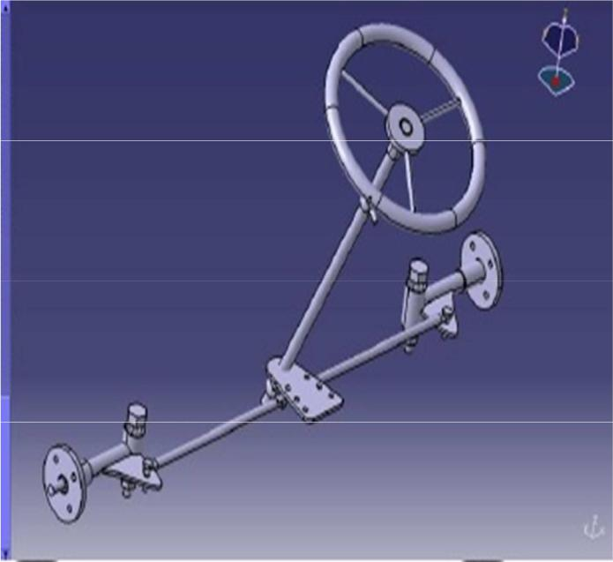

The formulae’s used for steering calculation are:

R = d/2+Lcosec (A/2+B/2)

% Ackerman = A-B/ tan-1(1/tanb -1) -B

Where,

R is the turning radius,

L is the length of the car,

A is the angle of the inside angle of the wheel

B is the angle of the outside wheel

d is the width of the car.

To determine the Ackerman percentage, equation

1. was used. Given that, 100% Ackerman angle is desired, A at 30-degrees and B at 22-degree was the best option. This gave a turning radius of

3.2m.In this geometry when a car taking a relative wide turn, the point where axel lines intersect is the point about which the car is turning.

King pin inclination is used to making a steering tend to return to the straight ahead or centre position. If kingpin is incline at 12 degree, it gives self centering effect and leads to less steering effort

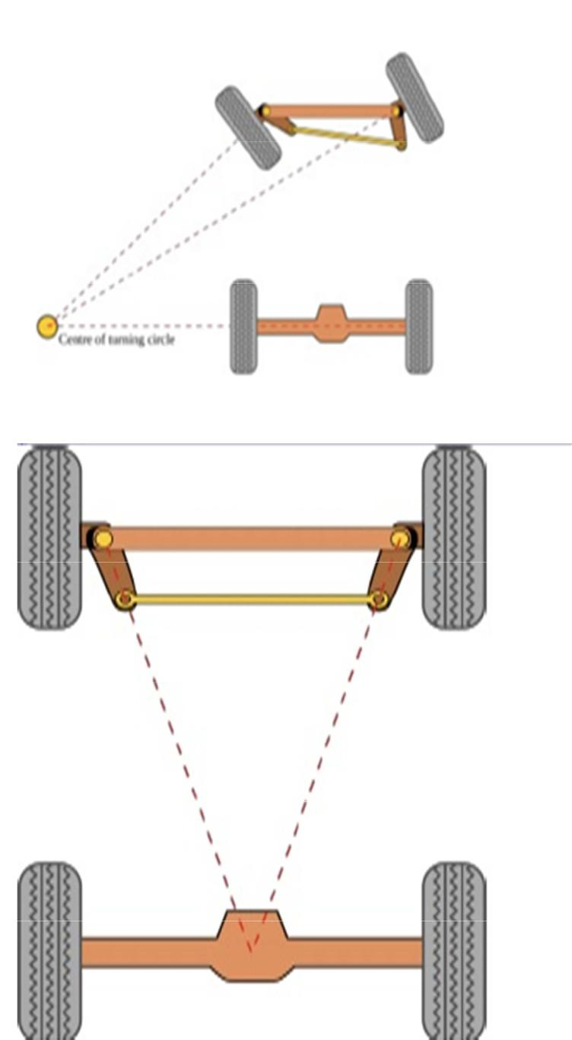

Our tires is not skidding because the inside front wheel is angled just a little more than the outside front wheel.

Inner and outer turning angle is calculated by the formulae

Outer angle-

tanA = L/(R-d/2)

Inside angle-

tanB = L/(R+d/2)

Caster angle is the most important factor governing how the kart will handle. It will make the kart more stable in rough condition and the kart’s straight line stability will also be improved

.**CALCULATIONS*-***

Various calculations are tabulated as follow according to the vehicle specifications

|  |  |
| --- | --- |
| Inner Turning Angle | 30 deg |
|  |  |
| Outer Turning Angle | 22 deg |
|  |  |
| Turning Radius | 3.2 m |
|  |  |
| Caster Angle | 0 deg |
|  |  |
| Camber Angle | 0 deg |
|  |  |
| King Pin Inclination | 0 deg |
|  |  |
| Tie Rod Length | 0.36 m |
|  |  |
| Steer wheel diameter | 14 inch |
|  |  |

**BRAKE SYSTEM-**

**OBJECTIVE:**

The purpose of the brakes is to stop the car safely and effectively. In order to achieve maximum performance from the braking system, the brakes have been designed to lock up rear wheels, while minimizing the cost and weight.

**DESIGN**

The brake system design includes the single disc at the rear axle to stop the vehicle. It is mounted in the one third part position of the axle with opposing the position of drive train sprocket hence also enables the good balancing requirement. Master cylinder is used at the front near the brake pedal providing the occupant to easily accessible space. A proper master cylinder bore size was found by doing brake calculations based on the mass, center of gravity, master cylinder volume size, and various dimensions of the vehicle. Though braking power increased with a decrease in bore size, the volume of brake fluid that was able to be displaced decreased with decreasing bore size.

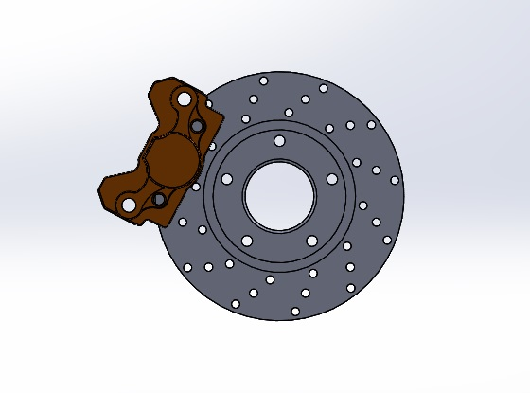

**FRONT AXLE**

Front axles are also analyzed against the axial load of tie roads that were placed on the port of tie rod joint to the front axle while steering is on work.The material used for the axles is ASI-1080 Theoretically calculated load of 490 N forces were placed on the axle in which the stress generated is under the safe mode and the factor of safety obtained is 1.8 hence the overall analysis shows that the axle would be safe while working on the specified load conditions.

**STEERING DESIGN CONSIDERATIONS**

|  |  |  |
| --- | --- | --- |
| **Consideration** | **Priority** | **Reason** |
| Simple Design | Essential | Minimize |
|  |  | weight to |
|  |  | maximize |
|  |  | Power to |
|  |  | weight ratio |
|  |  | of car |
| Low Steering Ratio | Essential | Quick |
|  |  | steering |
|  |  | response |
| Ackerman geometry | High | To avoid |
|  |  | skidding |
|  |  | without using |
|  |  | differentials |
| Minimize Bump steer | Desired | Conserve |
|  |  | momentum |
|  |  | while |
|  |  | Steering |

**BRAKE SYSTEM CALCULATIONS-**

As we know that the total kinetic energy of a vehicle at the time of breaking is converted into heat due to the friction of calliper pad on rotor disc. Kinetic energy E = ½ mv 2= 22,232 Nm

Where, m = mass of the vehicle = 170 kg

velocity of the vehicle = 16.67m/s

Stopping distance of the vehicle is calculated by Newton laws of motion formulae

V2 =u2 + 2aS

v is the final velocity of the vehicle

u is the initial velocity of the vehicle,

a is the acceleration of the vehicle and

Stopping time of the vehicle,

v=u + at

Where, Final velocity is 0, Initial velocity is 16.67 m/s, and stopping distance is 23.6 m, therefore,

t= u/a

= 2.83s

Braking force= µ*(kinetic energy/braking distance) = 565.2N

Braking torque= braking force * effective radius = 565.2*.1 = 56.2Nm

Force applied by the driver on the pedal is taken as 100N and pedal ratio is 4:1

The area of the piston of master cylinder is 1cm2.

Having the above values the brake system will work in proper manner and will satisfy the requirement. Here is the brake line block diagram which sates the position of various parts of the brake system-

All the calculated values are tabulated as follow-

|  |  |
| --- | --- |
| Disk Outer Diameter | 200 mm |
|  |  |
| Disk Inner Diameter | 120 mm |
|  |  |
| Thickness of Disk | 5 mm |
|  |  |
| Brake Pedal Force | 100 N |
|  |  |
| Pedal Ratio | 4 : 1 |
| Coefficient of Friction | 0.60 |
|  |  |
| Brake line pressure | 4 Mpa |
|  |  |
| Brake Torque | 52.8 Nm |
| Stopping Time | 2.8 sec |
| Stopping Distance | 23.6 m |

**TESTING-**

The break disc is also analysed in thermal module of ANSYS software in which the disc is analysed by placing the boundary conditions as temperature, convection i.e. (.55) ,coefficient of thermal expansion the total heat flux is calculated during the process as well as the heat generation .

**Brake specifications-**

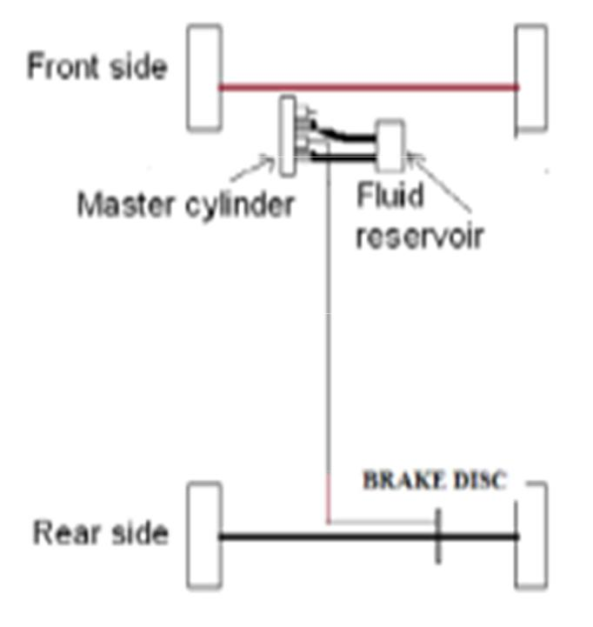

**DRIVE-TRAIN DESIGN-**

**OBJECTIVE:**

We are using the 11bhp, 125 cc engine. In this engine the horizontal output shaft is provided, which would be customize by us and the small sprocket would be attached to the shaft. Now the final drive would be a chain drive where the chain will attach to the rear sprocket mounted on the rear axle. Hence the final drive gear ratio is 2:1.

The drive-train is a very important part of the racing cars, taking into consideration that all of the car’s power is transferred through the drive-train system to the ground. The challenge is to harness the engine’s 8 brake horsepower and distribute it to the ground in the most efficient way. The drive-train needs to be able to operate in the lowest and highest gear ratios while performing in all of the different aspects of the competition

**DESIGN:**

The goal of the drive train is to transfer power from the engine of the vehicle to the wheels. The power transferred must be able to move the vehicle.

**ENGINE-**

We are using 125 cc, 11 bhp @ 8000 rpm engine for the power transmission.

Engine is mounted in the position above the rear axle on the rigid frame with the anti-vibration mountings the positioning of engine is decided on the basis of the availability of the space in the engine compartment of the frame.

The final drive gear ratio is 2:1.

Which is calculated by –

No. of teeths on sprocket 1- 14

No. of teeths on sprocket 2- 28

Where, T1 & T2 are the no of teeth in the sprockets driver and driven respectively. Now -

28

Gear Ratio-

14

Gear Ratio - 2: 1

Hence the gear ratio of the final drive which is 2:1 will provide the required torque to the vehicle to run. The modal of the final drive is shown here-

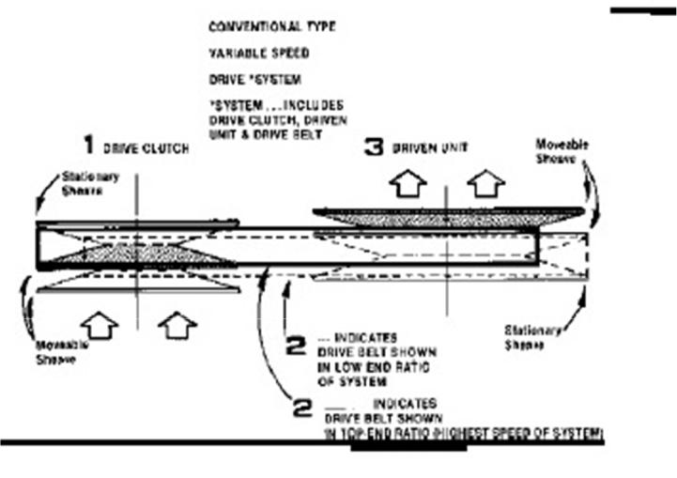

**WHEELS**-

The wheel is one of the main components of the wheel and axle which is one of the six simple machines. Wheels, in conjunction with axles, allow heavy objects to be moved easily facilitating movement or transportation while supporting a load. The selection of tires according to the requirement of performance, event, as well as bugged plays an important role. We are using the wheels of same size for front and rear. The size of the tires is

Front: 10*4.5-5

Rear: 11*7.1-5

The objective of selecting this tire is to get required ground clearance.

**COMPLETE 3D VIEW*:***

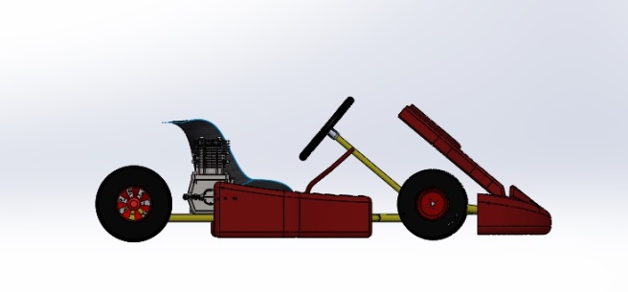

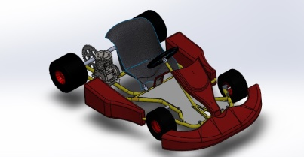

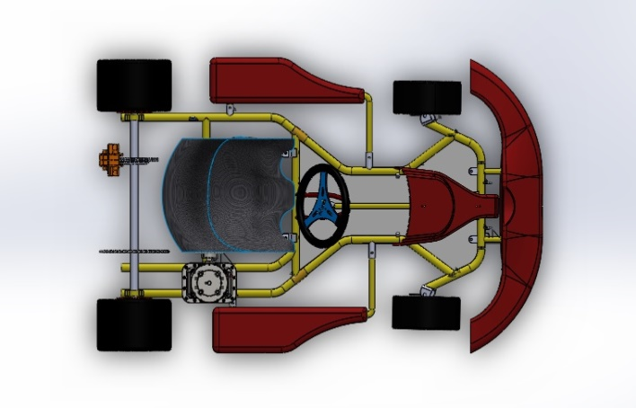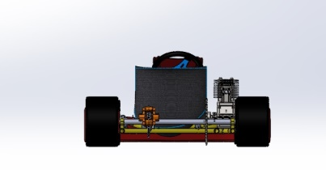

**TECHNICAL SPECIFICATION-**

|  |  |  |  |
| --- | --- | --- | --- |
| **VEHICLE** | **VALUE** | **VEHICLE** | **VALUE** |
| **MAKE** |  | **MAKE** |  |
| **MODEL** |  | **MODEL** |  |
| Wheel | 51.25 inch | Engine & | 125cc |
| Base |  | Transmissi | 11 Bhp |
|  |  | on | @ |
|  |  |  | 8000 |
|  |  |  | rpm |
| Wheel | 44.25 inch | Engine | 11 |
| track |  | Max. | Nm @ |
|  |  | Torque | 6500 |
|  |  |  | rpm |
|  |  | Max. Speed | 65kmph |
| Pedal ratio | 4:1 |  |  |
|  |  | Gear Ratio | 2:1 |
| Max disp. | 124.7 cc | (at rear axle) |  |
| Ground | 2 inch |  |  |
| clearance | min. | Outer diameter of material | 1 inch |
|  |  |  |  |
| Overall | 170kg | Wall thickness of material | 2 mm |
| weight |  |  |  |
| Material | AISI 1018 | Turning |  |
|  |  | radius | 3.2m |
| Tire size | Front: | Brake |  |
|  | 10*4.5-5 |  | 200 mm(O.D)  120 mm  (I.D) |
|  | Rear: |  |  |
|  | 11*7.1-5 |  |  |

**CONCLUSION**

THE VANQUISHERS team used the finite element analysis system to evaluate, create, and modify the best vehicle design to achieve its set goals. The main goal was to simplify the overall design to make it more light-weight without sacrificing performance and durability. The result is a lighter, faster, and more agile vehicle that improves go kart design.

The design and construction for GO-KART has become more challenging due to the increased participation. Our team is participating for the first time in this event so a detailed study of various automotive systems is taken as our approach. Thus this report provides a clear insight in design and analysis of our vehicle. The making of this report has helped us in learning of various software. We want to give a vote of Thank you in this regard as NKRC and IF9GKC competition has given as this opportunity to learn many things which will also help us in leading a bright future.

**REFERENCE**

1. TUNE TO WIN -Carroll Smith

2. Fundamentals of Vehicle Dynamics - Thomas a Gillespie

3. Automobile Engineering – Kirpal Singh

4. Wikipedia

5. Google Search engine